

CYPRUS INTERNATIONAL UNIVERSITY
FACULTY OF ENGINEERING

ENGI401, PROJECT MANAGEMENT
FEASIBILITY STUDY REPORT

PROJECT #2
RETRIEVAL-AUGMENTED GENERATION (RAG) SYSTEM FOR INTELLIGENT DOCUMENT Q&A

SUBMITTED BY

STUDENT NO. | NAME | DEPARTMENT
22208662 | PATRICIA NALEDY LUCAS | COMPUTER ENGINEERING
22118430 | OLIVIER BAGUMA MUSHAGALUSA | COMPUTER ENGINEERING
22200351 | COLLINS OBAKPONUVWE OVUAKPORAYE | COMPUTER ENGINEERING
22116175 | NATHAN MUKUNGA NGOYI | ARTIFICIAL INTELLIGENCE ENGINEERING
22210680 | KHALID MOHAMED FITW | SOFTWARE ENGINEERING

SUPERVISOR
Dr. Fuat Uyguroğlu

SEMESTER
FALL 2025-2026
TABLE OF CONTENTS
- INTRODUCTION
1.1 Purpose of the Feasibility Report
1.2 Project Description
1.3 Justification for the Proposed System
1.3.1 Limitations of Existing AI and LLM-Based Systems
1.3.2 Advantages of the Proposed RAG-Based System
1.4 Desired System Functionality
1.4.1 Generic Use Case Description
1.4.2 System Actors
1.4.3 High-Level Use Case Scenarios
- EXISTING SYSTEMS AND TECHNOLOGIES
2.1 Traditional Information Retrieval Systems
2.2 Standalone Large Language Model (LLM) Systems
2.3 Existing Retrieval-Augmented Generation (RAG) Platforms
2.4 Technologies Used in Modern RAG Systems
2.5 Limitations of Existing RAG and AI-Based Systems
- CONSIDERATIONS
3.1 Privacy and Data Protection
3.2 Technical Constraints and Limitations
3.3 Implementation Challenges
3.4 Social and Ethical Implications
3.5 Risk Evaluation and Mitigation Measures
- TIME, COST AND TECHNICAL FEASIBILITY
4.1 Time Feasibility
4.1.1 Work Breakdown Structure (WBS)
4.1.2 WBS Mapping with projected RoadMap (15 Weeks)
4.1.3 Critical Path Analysis
4.2 Technical Feasibility
4.2.1 System Architecture Overview
4.2.2 Document Ingestion and Chunking Mechanisms
4.2.3 Embedding Models and Vector Databases
4.2.4 Retrieval and LLM Integration
4.3 Cost Feasibility
4.3.1 Development and Infrastructure Costs
4.3.2 Software and API Cost Considerations
4.4 Overall Feasibility Assessment
- TEAM: JOB DESCRIPTION AND ACADEMIC ANALYSIS
5.1 Web Application Development Team
5.1.1 An Approach to the Web Application Development
5.2 System Design and Research Team
5.2.1 Some Approaches to System Design and Research
5.2.2 Summary
- REALISTIC CONSTRAINTS
6.1 Design Constraints
6.2 Engineering Standards and Lifelong Learning
6.2.1 Software Engineering Standards
6.2.2 Lifelong Learning
6.3 Ethical Issues
6.4 Health and Safety Problems
6.5 Social and Political Issues
6.6 Environmental Impact
6.7 Legal Consequences
- CONCLUSIONS
- REFERENCES

- INTRODUCTION

  - Purpose of the Feasibility Report
The purpose of this feasibility report is to evaluate the practicality and viability of developing and deploying a Retrieval-Augmented Generation (RAG) System as a capstone engineering project. This report examines whether the proposed system can be successfully designed, implemented, and operated within the given technical, time, and resource constraints, while delivering meaningful improvements over existing Artificial Intelligence (AI) and Large Language Model (LLM) solutions.
The feasibility study considers key dimensions including technical feasibility, operational feasibility, scalability considerations, and functional suitability, with the aim of determining whether the proposed RAG-based approach is appropriate for real-world information retrieval and question-answering scenarios. The findings of this report serve as a foundation for informed decision-making prior to full system development.

  - Project Description
The proposed project focuses on the design and implementation of a Retrieval-Augmented Generation (RAG) System that enhances the capabilities of traditional LLMs by integrating them with an external knowledge retrieval mechanism. Instead of relying solely on pre-trained model parameters, the system dynamically retrieves relevant information from a curated knowledge base and uses it as contextual input for response generation.
The RAG system is intended to support domain-specific question answering, document analysis, and contextual information retrieval, particularly in scenarios where accuracy, traceability, and up-to-date knowledge are critical. The system architecture combines document ingestion, text chunking, vector embedding, similarity-based retrieval, and LLM-driven generation into a unified pipeline.

This project is designed as a research-oriented capstone study that prioritizes the analysis, evaluation, and validation of Retrieval-Augmented Generation (RAG) methodologies, with software components serving primarily as experimental instruments rather than as the end product. The emphasis is placed on understanding system behavior, performance trade-offs, and design decisions in RAG-based architectures.

  - Justification for Proposed System
The rapid adoption of LLMs has demonstrated their potential in natural language understanding and generation. However, existing systems exhibit several limitations that restrict their effectiveness in structured, knowledge-intensive environments. The proposed RAG-based system is justified as a solution that directly addresses these shortcomings.
    - Limitations of Existing AI and LLM-Based Systems
Traditional LLM-based systems generate responses based solely on knowledge encoded during pre-training. This design introduces several key limitations:
- Knowledge Staleness: LLMs cannot inherently access or reason over newly updated or proprietary information without retraining.
- Hallucination Risk: Models may generate confident but incorrect responses when factual grounding is absent.
- Lack of Source Transparency: Users cannot easily verify where generated information originates.
- Poor Domain Adaptability: Applying LLMs to specialized domains requires costly fine-tuning or extensive prompt engineering.
- Scalability Challenges: Large context windows increase computational cost and latency when processing long documents.
These constraints make standalone LLM systems unsuitable for applications that demand accuracy, accountability, and contextual grounding.

    - Advantages of the Proposed RAG-Based System
The proposed RAG system overcomes the above limitations by combining information retrieval with language generation, offering several advantages:
- Improved Accuracy: Responses are grounded in retrieved documents rather than relying solely on probabilistic generation.
- Reduced Hallucinations: The LLM is constrained by factual context provided during retrieval.
- Up-to-Date Knowledge Access: The knowledge base can be updated independently of the model.
- Explainability: Retrieved documents can be referenced, enabling transparency and validation.
- Modular Scalability: Retrieval, embedding, and generation components can be independently optimized or replaced.
These advantages make the RAG approach particularly suitable for academic, enterprise, and technical information systems.

  - Desired System Functionality
The desired functionality of this proposed RAG system focuses on delivering an efficient, accurate, and user-friendly information retrieval and generation pipeline. The system is designed to support both end users and administrators through clearly defined interactions and workflows.
    - Generic Use Case Description
The system operates by allowing a user to submit a natural language query. Upon receiving the query, the system converts it into a vector embedding and performs a similarity search against a vectorized document repository. The most relevant document chunks are retrieved and injected into the prompt context of the LLM, which then generates a response grounded in the retrieved information.
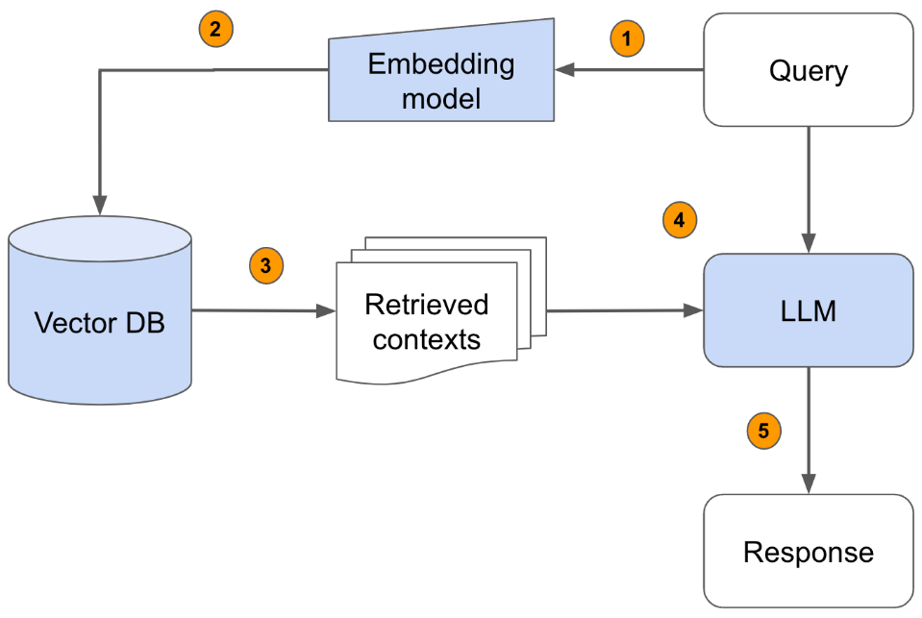
Figure 1: The Query-to-Response Processing Flow Diagram of a RAG System
    - System Actors
The RAG system involves the following primary actors:
- End User
  - Submits natural language queries (questions)
  - Receives generated, context-aware responses
  - Interacts with the system through a user interface or API
- System Administrator
  - Manages document ingestion and updates
  - Configures system parameters such as chunk size and embedding models
  - Monitors system performance and logs
- RAG System (Backend Services)
  - Handles embedding generation, retrieval, and response synthesis
  - Coordinates interactions between vector databases and LLM services

    - High Level Use Case Scenarios
The core operational scenarios of the RAG system include:
- Document Ingestion and Indexing:
Administrators upload documents, which are processed, chunked, embedded, and stored in a vector database.
- Query Processing and Retrieval:
A user submits a query, which is embedded and matched against stored document vectors to retrieve the most relevant context.
- Response Generation:
Retrieved context is combined with the user query and passed to the LLM to generate a grounded and coherent response.

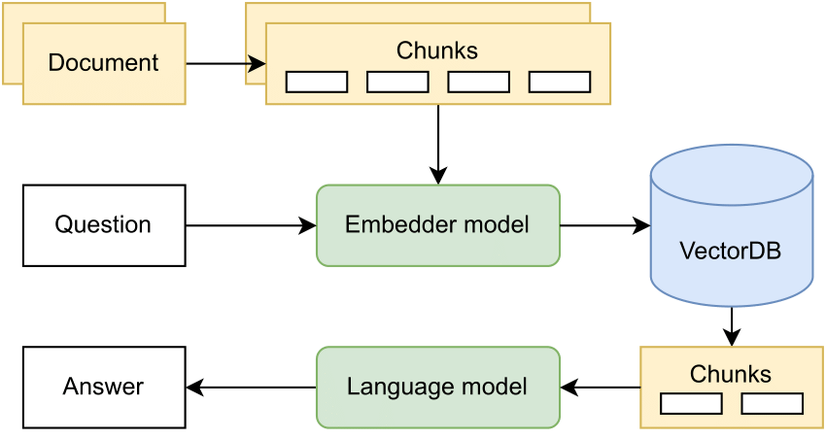
Figure 2: High-level model diagram of a RAG System Architecture

The system is expected to support the following core functionalities:
- Document upload and ingestion
- Configurable chunking strategies
- Embedding generation using multiple models
- Vector indexing and semantic similarity search
- Query handling and retrieval ranking
- LLM-based response generation
- Display of retrieved sources for transparency
- Web-based user interactions
From an academic perspective, RAG systems offer a rich research space, sitting at the intersection of:
- Information retrieval
- Natural language processing
- Machine learning systems engineering
- Human-computer interaction
This makes RAG an ideal capstone topic for a multidisciplinary engineering team like the one assembled for this project.
- EXISTING SYSTEMS AND TECHNOLOGIES
The development of a Retrieval-Augmented Generation (RAG) system must be grounded in a clear understanding of prior information retrieval paradigms, the evolution of large language models, and the hybrid systems that attempt to combine both. This chapter surveys the existing systems and technologies relevant to RAG, focusing on their theoretical foundations, operational characteristics, and known limitations. Rather than presenting a product comparison, this review positions RAG as an emerging research direction motivated by observable gaps in traditional and modern AI systems.

  - Traditional Information Retrieval Systems
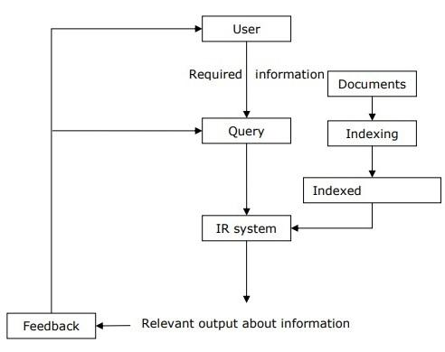
Figure 4; shows a traditional Natural Language Processing - Information Retrieval Model
Traditional, Information Retrieval (IR) systems are designed to locate relevant documents from large corpora based on user queries. These systems form the conceptual backbone of search engines, digital libraries, and enterprise knowledge management platforms.
Classical IR methods rely on “lexical matching”, where documents are indexed using techniques such as inverted indexes, term frequency–inverse document frequency (TF-IDF), or Boolean logic. Queries are processed by matching keywords against stored representations, and relevance is computed using similarity metrics defined in vector space models.
While these systems are computationally efficient and transparent, they suffer from fundamental limitations:
- Lack of semantic understanding: Traditional IR systems treat text as a collection of tokens rather than meaningful concepts.
- Vocabulary mismatch problem: Relevant documents may be missed if they do not share exact terms with the query.
- Static retrieval behavior: Results are retrieved, not synthesized or reasoned over.
From a research perspective, traditional IR systems are highly reliable for “fact lookup” but inadequate for knowledge synthesis, reasoning, or explanation, which are increasingly demanded by modern users.

  - Standalone Large Language Model (LLM) Systems
Standalone Large Language Models (LLMs) represent a paradigm shift from retrieval-based systems toward generative intelligence. Trained on massive text corpora, these models learn statistical patterns in language and are capable of producing coherent, contextually relevant responses.
Systems such as those developed by OpenAI and Google demonstrate impressive capabilities in summarization, question answering, and natural language reasoning. However, from a feasibility and research standpoint, standalone LLMs exhibit critical weaknesses:
- Knowledge cutoff: Models are limited to the data available at training time.
- Hallucination risk: LLMs may generate plausible but incorrect or unverifiable information.
- Opacity: The reasoning process is implicit and difficult to audit.
- No explicit grounding: Outputs are not directly tied to external, verifiable sources.
These characteristics (aforementioned weaknesses) make standalone LLMs unsuitable for applications that require factual reliability, traceability, or domain-specific accuracy. As a result, research has increasingly focused on augmenting LLMs with external knowledge mechanisms.

  - Existing Retrieval-Augmented Generation (RAG) Platforms
Retrieval-Augmented Generation (RAG) systems aim to combine the precision of retrieval systems with the flexibility of generative models. In a typical RAG pipeline, user queries are first transformed into vector embeddings, used to retrieve relevant documents from an external knowledge base, and then injected into the LLM’s context for response generation.
Several experimental and commercial RAG-based platforms exist today, often embedded in enterprise search tools, customer support systems, or research assistants. These systems demonstrate measurable improvements in answer accuracy and contextual relevance, particularly in specialized domains.
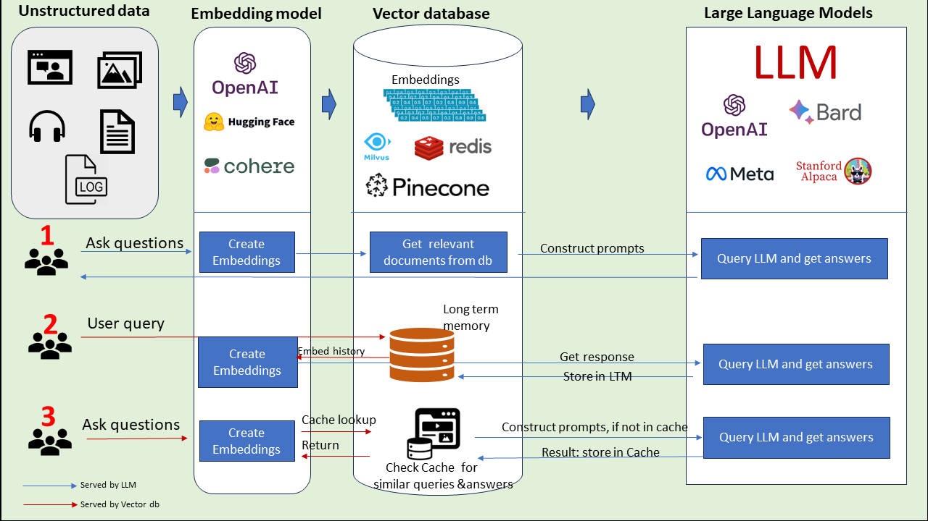
Figure 5; Three ways Vector Databases take LLM use cases to the next level
However, existing RAG platforms are still an active area of research rather than a mature technology. Open challenges include:
- Retrieval noise and irrelevant context injection
- Sensitivity to chunking strategies
- Context window limitations
- Lack of standardized evaluation metrics
Consequently, RAG should be viewed not as a solved engineering problem, but as a research framework requiring systematic analysis, experimentation, and validation.

  - Technologies Used in Modern RAG Systems
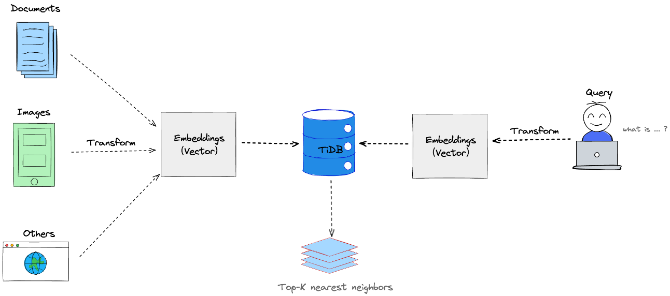
Figure 6; shows an overview of Vector Searching
Modern RAG Systems are built upon several interdependent technologies:
- Text Embeddings: Dense vector representations that capture semantic meaning.
- Vector Databases: Specialized databases optimized for similarity search in high-dimensional spaces.
- Similarity Metrics: Measures such as cosine similarity used to rank retrieved content.
- Prompt Augmentation: Techniques for injecting retrieved context into LLM prompts.
- Transformer-based LLMs: Generative models responsible for final output synthesis.
From a research perspective, each of these components introduces design trade-offs that influence system performance. For example, embedding dimensionality affects retrieval precision, while chunk size impacts semantic coherence. The interaction between these elements is non-trivial and forms a central focus of RAG research.

  - Limitations of Existing RAG and AI-Based Systems
Despite their promise, existing RAG and AI-based systems exhibit several unresolved limitations that motivate further investigation:
- Retrieval dependency: Poor retrieval quality directly degrades generation quality.
- Evaluation difficulty: There is no universally accepted benchmark for RAG correctness.
- Latency overhead: Multi-stage pipelines introduce additional response time.
- Context dilution: Excessive retrieved content may confuse the language model.
- Explainability gaps: Although grounded, reasoning paths remain largely implicit.
These limitations highlight why this capstone project is framed as a research-oriented feasibility and evaluation study, rather than a purely software-centric implementation. Understanding when, why, and how RAG systems succeed or fail is as important as building them.

- CONSIDERATIONS
This chapter discusses the critical considerations surrounding the proposed Retrieval-Augmented Generation (RAG) Capstone project. Since this project is also a research-oriented investigation of RAG methodologies, the focus is placed on conceptual limitations, ethical risks, and evaluative constraints rather than full-scale system deployment. These considerations are essential in assessing the feasibility, responsibility, and academic value of the project.

  - Privacy and Data Protection
One of the most significant considerations in a RAG-based research system is the handling of data used for retrieval and evaluation. Although the proposed project does not aim to build a production-level system, it still interacts with document collections that may contain sensitive, proprietary, or personally identifiable information (PII).
From a research perspective, privacy concerns arise primarily during dataset selection, preprocessing, and evaluation. Any datasets used must either be publicly available, anonymized, or synthetically generated to avoid legal and ethical violations. Special care must be taken to ensure that embeddings generated from documents do not unintentionally expose sensitive information through reconstruction or inference attacks.
Additionally, the research must account for data retention and access control policies, even in an academic context. Stored embeddings, retrieved passages, and evaluation logs should be treated as sensitive research artifacts and protected accordingly. Ethical research practice requires transparency regarding how data is sourced, stored, and disposed of once the study concludes.

3.2 Technical Constraints and Limitations
The proposed RAG system is subject to several technical constraints that directly influence the scope and validity of the research findings. Unlike industrial systems, this project operates under limited computational resources, restricted access to large-scale proprietary models, and constrained experiment timelines.
Key limitations include:
- Restricted model sizes due to hardware constraints.
- Limited dataset scale, which may affect generalizability.
- Dependence on pre-trained embedding models rather than training from scratch.
- Variability in retrieval performance caused by chunking strategies, indexing methods, and similarity metrics.
From a research standpoint, these constraints are not weaknesses but explicit experimental boundaries. They must be clearly documented to contextualize results and avoid overgeneralization. The research objective is not to achieve optimal industrial performance, but to compare, analyze, and evaluate design trade-offs within realistic academic constraints.

  - Implementation Challenges
Even within a research-focused project, implementation challenges remain relevant because they influence experimental validity and reproducibility. Integrating retrieval mechanisms with generation models introduces complexity in pipeline orchestration, experiment tracking, and result interpretation.
Major challenges include:
- Ensuring consistency between retrieval results across experiments.
- Managing variations in output due to non-deterministic LLM behavior.
- Designing evaluation protocols that isolate retrieval quality from generation quality.
- Preventing confounding variables when comparing different RAG configurations.
Furthermore, ensuring reproducibility is a key research challenge. Differences in model versions, embedding libraries, or indexing methods can significantly impact results. Addressing these challenges requires careful documentation, controlled experimentation, and transparent reporting rather than extensive system engineering.

3.4 Social and Ethical Implications
RAG Systems raise important social and ethical questions, particularly concerning information reliability, bias amplification, and misuse of generated content. Even in an academic setting, these implications must be critically examined.
Retrieved documents may contain biased, outdated, or incorrect information, which can then be reinforced by the generative model. This creates a risk of false authority, where generated answers appear credible despite flawed sources. From a research perspective, this underscores the importance of evaluating not only answer quality but also source relevance, diversity, and trustworthiness.
Ethically, the project must avoid presenting RAG outputs as factual truths. Instead, results should be framed as probabilistic and context-dependent, with explicit acknowledgment of limitations. This approach reinforces responsible AI research practices and prevents misinterpretation of findings by non-expert audiences.

3.5 Risk Evaluation and Mitigation Measures
Several methodological, operational issues may affect the success and integrity of this project. A few of them are discussed subsequently:
Poor Retrieval Accuracy: This represents a critical risk in a Retrieval-Augmented Generation research system, as the quality of retrieved documents directly influences the correctness, relevance, and factual grounding of generated responses. Inaccurate or weak retrieval may result in irrelevant context being supplied to the language model, leading to hallucinations or misleading outputs. This risk is particularly significant in research settings where conclusions about RAG effectiveness depend on retrieval quality. To mitigate this, multiple chunking strategies and embedding models are systematically evaluated to identify configurations that maximize semantic relevance. Comparative experimentation allows the research to quantify how retrieval design choices influence downstream generation performance.
API Instability: Reliance on external APIs for large language models or embedding generation introduces the risk of service interruptions, rate limits, or model version changes, which may disrupt experimental continuity. Such instability can affect reproducibility, especially when experiments must be repeated over time or compared across configurations. In a research-oriented project, this risk threatens the consistency of evaluation results rather than system availability. Mitigation involves the use of local or open-source model alternatives as fallback options to preserve experimental workflows. Documenting model versions and inference conditions further ensures that results remain interpretable despite external dependencies.
Time Overruns: Time overruns pose a high risk due to the constrained academic schedule of a capstone project and the iterative nature of experimental research. RAG systems often require repeated cycles of retrieval tuning, prompt adjustment, and evaluation refinement, which can exceed initial time estimates. Without careful planning, this may result in incomplete experimentation or shallow analysis. To mitigate this risk, the project is structured into modular milestones, each producing independently analyzable results. This approach ensures that partial findings remain valuable even if later experimental phases must be reduced or deferred.
Evaluation Bias: Evaluation bias is a significant methodological risk in RAG research, as subjective judgments or reliance on a single metric may distort conclusions about system performance. Human-only evaluation can introduce personal interpretation bias, while automated metrics alone may fail to capture answer usefulness or factual grounding. This risk is particularly relevant when comparing multiple retrieval or generation strategies. Mitigation is achieved through the use of multiple evaluation metrics, combining quantitative measures (e.g., relevance or similarity scores) with structured qualitative analysis. This triangulated evaluation approach improves reliability and strengthens the validity of research findings.
Overall, the considerations outlined in this chapter show that the feasibility of the proposed RAG Capstone project is grounded in the deliberate integration of experimental software components with systematic analysis, rather than in the deployment of a production-ready system. By addressing privacy requirements, technical and implementation constraints, and risk management considerations alongside research objectives, the project ensures that its design decisions, experimental results, and engineering trade-offs are technically justified, methodologically sound, and responsibly evaluated.

- TIME, COST AND TECHNICAL FEASIBILITY
This chapter evaluates the feasibility of the proposed Retrieval-Augmented Generation (RAG) Capstone System from three complementary perspectives: time, technical capability, and cost. In alignment with the project’s research-driven orientation, feasibility is assessed not by the standards of a production-grade commercial system, but by the system’s ability to support controlled experimentation, comparative analysis, and academic validation of RAG design choices.

4.1 Time Feasibility
This evaluates whether the proposed research activities, system implementation, experimentation, and reporting can be completed within a single Spring semester, while respecting academic constraints such as coursework, examinations, and submission deadlines defined by the university’s Academic Calendar

    - Work Breakdown Structure (WBS)
The project is decomposed into manageable activities using a Work Breakdown Structure, consistent with ENGI401 project management principles. The WBS emphasizes research milestones first, followed by implementation and evaluation. It is as follows:
- Project Initiation & Planning
  - Finalize project scope and objectives
  - Literature review on RAG architectures and retrieval methods
  - Define experimental variables and evaluation metric
- System (Research-Oriented) and Interface Design
2.1 RAG system architecture design
2.2 Web application architecture (frontend–backend interaction)
2.3 UX/UI design for document upload, querying, and answer visualization
- Core RAG Backend Implementation
3.1 Document ingestion and preprocessing pipeline
3.2 Chunking strategies and configuration
3.3 Embedding generation and vector database indexing
D. Retrieval, LLM & API Integration
4.1 Similarity search and retrieval pipeline
4.2 Prompt construction and context injection
4.3 LLM API integration and response handling
E. Web Application Development
5.1 Frontend implementation (upload, query input, results display)
5.2 Backend API endpoints and orchestration
5.3 Frontend–backend integration and error handling
F. Experimental Evaluation
6.1 Dataset preparation and test query design
6.2 Controlled experiments (chunk size, overlap, retrieval depth)
6.3 Logging, measurement, and result validation
G. Analysis, Documentation & Reporting
7.1 Analysis of experimental and system performance results
7.2 Discussion of trade-offs (accuracy, latency, usability)
7.3 Final report writing and revisions

    - WBS Mapping with projected RoadMap (15 Weeks)
Week(s) | WBS Reference | Primary Activities
1 | 1.1 | Finalize project scope; core RAG literature review
2 | 1.2 | Literature review on RAG & related systems
3 | 1.3 | Define evaluation metrics and experimental variables
4 | 2.1 | RAG system architecture design
5 | 2.2 – 2.3 | Web app architecture + UI/UX design
6 | 3.1 | Document ingestion and preprocessing
7 | 3.2 | Chunking strategies and configuration
8 | 3.3 | Embeddings and vector database indexing
9 | 4.1 | Retrieval logic and similarity search
10 | 4.2 – 4.3 | Prompting strategy and LLM integration
11 | 5.1 | Frontend implementation
12 | 5.2 – 5.3 | Backend APIs and full-stack integration
13 | 6.1 | Dataset preparation and test queries
14 | 6.2 – 6.3 | Controlled experiments and validation
15 | 7.1 – 7.3 | Analysis, discussion, and final report

    - Critical Path Analysis
The critical path for the Capstone RAG System consists of:
Literature review and research definition (Weeks 1–3: 3 Wks.) → System and web architecture design (Weeks 4–5: 2 Wks.) → Core RAG backend implementation (Weeks 6–10: 5 Wks.) → Web application integration (Weeks 11–12: 2 Wks.) → Experimental evaluation and validation (Weeks 13–14: 2 Wks.) → and Final analysis and report writing (Week 15: 1 Wk.).
Activities on this path possess zero total float, and any delay in these stages will directly affect the final project submission date. The path can be aligned so that:
- Research and architecture design - occur before midterms
- Implementation and experimentation - span the mid-semester period
- Analysis and report writing - conclude before finals
The project is time-feasible, provided the research scope remains focused and experimentation is prioritized over feature expansion.

  - Technical Feasibility
Technical feasibility examines whether the proposed RAG system can be designed, implemented, and evaluated using available knowledge, tools, and infrastructure, while remaining suitable for academic research rather than production deployment.
    - System Architecture Overview
The System follows a modular RAG architecture (as shown in Figure 2), deliberately structured to allow controlled variation of components for research comparison. Each module can be independently modified, enabling systematic evaluation of design decisions.
Core architectural layers include:
- Document ingestion and preprocessing
- Text chunking and representation
- Embedding generation
- Vector-based retrieval
- Prompt augmentation and LLM generation
This modularity is critical for experimental rigor rather than operational efficiency.

    - Document Ingestion and Chunking Mechanisms
Document ingestion supports formats such as PDF, DOCX, and TXT. From a research perspective, the ingestion pipeline is not optimized for throughput but for traceability and repeatability.
Chunking strategies are treated as experimental variables, including:
- Fixed-length chunks
- Overlapping vs. non-overlapping windows
- Semantic vs. syntactic segmentation
This enables analysis of how chunk size and overlap influence retrieval relevance and hallucination risk.

    - Embedding Models and Vector Databases
Embedding generation relies on pre-trained models, avoiding costly fine-tuning while allowing comparison between:

- General-purpose embeddings
- Domain-sensitive embeddings (if applicable)
Vector databases (e.g., FAISS or Chroma) are selected for:
- Deterministic behavior
- Local execution
- Transparent indexing mechanisms
The goal is experimental control, not large-scale scalability.

    - Retrieval and LLM Integration
Retrieval uses similarity search (e.g., cosine similarity) to select top-k chunks. These are injected into structured prompts passed to an LLM. From a research standpoint, emphasis is placed on:
- Prompt construction strategies
- Retrieval depth trade-offs
- Context window limitations
LLM responses are evaluated qualitatively (answer grounding, coherence) and quantitatively (retrieval precision proxies).
All components rely on well-documented, mature technologies, making the system technically feasible for a capstone-level research project without requiring advanced infrastructure or proprietary tooling.

  - Cost Feasibility
Cost feasibility assesses whether the project can be completed within realistic student budgets, using the financial assumptions outlined in the project proposal document.

    - Development and Infrastructure Costs
Cost Category | Estimated Costs (USD) | Notes
LLM API Credits | $50–100 | Development + testing
Vector DB Hosting | $0–50 | Free/local tiers used
Web Hosting (Optional) | $0–20/month | Research demo only
Hardware | $0 | Personal computers
Total Estimated Costs | $50–150 | Within team budget

The use of local execution and free tiers ensures costs remain predictable.

    - Software and API Cost Considerations
All core core software components are either:
- Open-source, or
- Consumption-based APIs with strict usage limits
No proprietary licenses are required. Costs scale linearly with experimentation volume, allowing expenditure to be controlled by limiting API calls during evaluation phases.
The project is financially feasible, with costs justified by the educational and research value generated. The low-cost profile aligns with academic ethics and sustainability considerations.

  - Overall Feasibility Assessment
When evaluated holistically:
- Time Feasibility: Achievable within the Spring semester
- Technical Feasibility: Supported by mature, accessible technologies
- Cost Feasibility: Well within student and academic constraints
Most importantly, the project is feasible as a research instrument, capable of generating meaningful insights into RAG system design, limitations, and trade-offs rather than serving as a production application.

- TEAM: JOB DESCRIPTION AND ACADEMIC ANALYSIS
This chapter outlines the division of responsibilities within the project team and provides an academic analysis of how each sub-team contributes to the overall objectives of the Retrieval-Augmented Generation (RAG) capstone. Rather than emphasizing implementation alone, the discussion focuses on methodological reasoning, design justification, and research alignment, reflecting the exploratory and evaluative nature of the project.
This division of responsibility ensures that the capstone project remains grounded in academic inquiry, with clear traceability between design assumptions, implementation choices, and observed outcomes.

  - Web Application Development Team
This duo is responsible for designing and implementing the user-facing interface through which the RAG system is accessed and evaluated.
- Patricia Naledy Lucas and
- Khalid Mohamed Fitw
jointly lead this component, ensuring that the web interface supports document upload, query submission, response visualization, and citation display in a manner that facilitates both usability and experimental observation. Their role is not limited to visual presentation; rather, the web application is treated as an experimental instrument through which user interactions, response latency, and retrieval transparency can be examined.

5.1.1 An Approach to the Web Application Development
The web application development approach proposed by Patricia and Khalid is designed to support the RAG system primarily as a; “research interaction layer rather than a production-oriented application”.
The core objective of the web application is to enable controlled, repeatable interaction with the document-based question answering pipeline, thereby facilitating systematic evaluation of retrieval and generation behavior.
When designing the frontend architecture, emphasis will be on simplicity, modularity, and reliability. By using a component-based design, the interface will support essential research tasks such as document upload, conversational querying, citation visualization, and error handling without introducing unnecessary complexity. Type safety and predictable UI behavior will be prioritized to minimize implementation-induced variability during experimentation. Performance considerations, including lightweight initial load size and responsive interaction, are treated as necessary conditions to prevent interface latency from influencing user behavior or evaluation outcomes.
On the backend, the system is structured as a lightweight coordination layer responsible for handling API requests, managing authentication, processing file uploads, and mediating communication with the machine learning and retrieval services. The backend is intentionally kept simple and transparent to allow easier debugging, monitoring, and interpretation of system behavior during testing phases. Scalability and microservice decomposition are acknowledged as future possibilities but are not treated as immediate requirements within the academic scope of the project.
Data management follows a “dual-database” approach that separates structured application data from vector embeddings. This separation improves analytical clarity by isolating conversational metadata and system logs from semantic retrieval operations. Integration between frontend, backend, databases, and external services is handled through well-defined interfaces to ensure stable system behavior and consistent response times during experiments.
Overall, this approach frames the web application as an “experimental enabler”, ensuring that observed system performance reflects the properties of the RAG pipeline itself rather than artifacts of interface design or infrastructure complexity.
Web Technologies, Frameworks, and Tools considered:
- Frontend – React, TypeScript, Vite
- Backend – Node.js, Express.js
- Databases – PostgreSQL (relational application data), Pinecone/Chroma DB (vector database for embeddings)
- Integration and Utilities – RESTful APIs, JWT-based authentication, Prisma ORM, Multipart file upload handling, Pinecone/Chroma SDK

5.2 System Design and Research Team
This group is responsible for defining the conceptual design, methodological foundations, and evaluation criteria of the RAG system.
- Olivier Baguma Mushagalusa,
- Collins Obakponuvwe Ovuakporaye, and
- Nathan Mukunga Ngoyi
collectively focus on the analytical design of the retrieval pipeline, embedding strategies, generation constraints, and citation mechanisms.
Rather than treating the system as a fixed engineering artifact, this team frames the RAG pipeline as a research object. Their work emphasizes comparative analysis, design justification, and methodological trade-offs across chunking strategies, embedding models, vector databases, and grounding techniques. The team’s output directly supports academic objectives such as reproducibility, evaluation rigor, and interpretability, aligning the system with research expectations rather than production benchmarks.

5.2.1 Some Approaches to System Design and Research
This section presents distinct but complementary research approaches, each derived strictly from the respective students’ academic analysis of the project.
Collins’s – RAG System Approach: This approach presents a “practically grounded and academically defensible blueprint” for building a Retrieval-Augmented Generation (RAG) system, with a strong emphasis on correctness, transparency, and evaluability.
The design follows a clearly staged RAG pipeline consisting of document ingestion, text extraction, chunking with overlap, embedding generation, vector storage, retrieval, and guarded generation. Each stage is treated as a controllable research variable rather than a black-box engineering step.
A central contribution of this approach is its detailed treatment of chunking strategies, identifying chunk size and overlap as primary determinants of retrieval quality. The use of fixed-size chunking with overlap is justified as a balance between retrieval accuracy and implementation simplicity, making it suitable for systematic experimentation. Embeddings are generated using Sentence Transformers, selected for their strong semantic performance, low cost, and offline capability., factors that support reproducibility in an academic environment.
Collins also places “significant emphasis” on citation mapping and guardrails, identifying them as critical to both grading criteria and research validity. By enforcing metadata-linked citations, retrieval-constrained prompting, low-temperature generation, and strict context isolation, the approach minimizes hallucination and ensures that all generated answers are traceable to retrieved document segments. The proposed phased-build sequence further reinforces a correctness-first methodology, ensuring that retrieval quality and grounding are validated before user-facing integration. Overall, this approach frames the RAG system as a “measurable, auditable research artifact” rather than a purely functional application.

Olivier’s – RAG System Approach: This approach focuses on “feasibility, clarity, and end-to-end system reasoning”, presenting the RAG system as a practical yet research-aligned solution for improving AI answer quality.
The primary goal of the system is to reduce hallucination by ensuring that responses are generated from retrieved, real-world documents rather than model memory alone. This can be achieved for example; by providing well written/engineered system prompts to the LLM(s), that serve as a deterrent to it providing any context outside the uploaded documents.
The approach clearly articulates the purpose and benefits of RAG, emphasizing improved accuracy, consistency, context awareness, and user trust. Olivier outlines the required technical components; LLMs, embedding models, vector databases, and backend orchestration., while maintaining an accessible explanation of how these components interact. This clarity supports both implementation feasibility and academic evaluation, as system behavior can be easily traced across stages.
A notable aspect of this approach is its focus on “tool justification and workflow explanation”, including data cleaning, chunking, embedding creation, storage, retrieval, and reranking. By explicitly describing each step, Olivier’s approach makes the system understandable not only to developers but also to evaluators. The inclusion of evaluation metrics such as accuracy, relevance, latency, and consistency further reinforce the system’s research orientation. Overall, this approach positions the RAG system as a structured, explainable, and academically suitable AI assistant, designed to be both useful and analytically transparent.

Nathan’s – RAG System Approach: This approach provides a “conceptual and explanatory foundation” for the RAG system, focusing on why Retrieval-Augmented Generation is necessary and how it improves trust, accuracy, and consistency in language model outputs.
The system is motivated by the “inherent limitations of large language models”, including static knowledge, hallucination, and overconfidence when uncertain.
The approach adopts a retrieval-first, generation-second architecture, explicitly defining external documents as the primary source of truth and positioning the language model as a reasoning and synthesis component rather than an authority. This design choice is academically significant, as it reframes the role of the LLM in a way that supports transparency, explainability, and user trust. Nathan emphasizes modularity, separating knowledge preparation from query-time processing, which allows independent evaluation of indexing, retrieval, and generation performance.
Tool selection is discussed from a research justification perspective, highlighting how embedding models, vector databases, and prompt engineering collectively determine system behavior. Particular attention is given to context-aware prompt augmentation, ensuring that retrieved content meaningfully constrains generation. The approach also contrasts RAG with traditional semantic search, clarifying how RAG extends retrieval by enabling reasoning and synthesis over retrieved evidence. Overall, Nathan’s contribution strengthens the project’s theoretical grounding, ensuring that design decisions are clearly motivated by known limitations of LLMs and by academic requirements for reliability and verifiability.

5.2.2 Summary
Collectively, all three approaches presented in this section demonstrate a coherent and research-driven perspective on the design and evaluation of a Retrieval-Augmented Generation (RAG) system. While each approach emphasizes different aspects of the system, they converge on a shared objective: improving the reliability, transparency, and factual grounding of language model outputs through structured retrieval and controlled generation.
Together, these approaches reinforce the project’s identity as a research-oriented investigation rather than a purely software-centric build. Their combined insights provide a balanced framework that integrates theoretical justification, methodological rigor, and practical feasibility, forming a solid foundation for the design, implementation, and evaluation of the proposed RAG system.

- REALISTIC CONSTRAINTS
The proposed Retrieval-Augmented Generation (RAG) Capstone project is subject to a set of realistic constraints that shape its scope, methodology, and achievable outcomes. Unlike production-oriented software systems, the primary objective of this project is to evaluate, compare, and reason about RAG design decisions under constrained academic conditions, rather than to deliver a fully scalable commercial platform.
These constraints are therefore treated not as obstacles, but as controlled variables that define the research and development environment, ensuring academic rigor, feasibility, and reproducibility within a single academic semester

  - Design Constraints
The design of the RAG system is constrained by limitations in time, budget, computational resources, and dataset scope. The system is intentionally focused on architectural clarity and experimental control rather than production-grade robustness.
Key design constraints include:
- Limited dataset size: Document collections are restricted to small-to-medium corpora (e.g., academic PDFs, reports, lecture notes) to ensure tractable experimentation and repeatable evaluation.
- Simplified system architecture: Modular components (chunking, embeddings, retrieval, generation) are implemented in isolation to allow comparative analysis rather than end-to-end optimization.
- Latency tolerance: Response times are acceptable within a research context and are not optimized for real-time deployment.
- Evaluation-driven design: Design decisions prioritize measurability (retrieval accuracy, answer relevance, citation grounding) over user experience polish.
These constraints enable focused investigation into how individual RAG components affect output quality while avoiding over-engineering

  - Engineering Standards and Lifelong Learning
Although the proposed RAG system is framed primarily as a research-oriented capstone rather than a production-grade software product, adherence to established engineering and software development standards remains essential. These standards provide a structured framework that ensures methodological rigor, technical reliability, and academic credibility, while also supporting reproducibility and comparative evaluation of different RAG design choices.

    - Software Engineering Standards
From a software engineering perspective, the project follows widely accepted standards not to enforce industrial compliance, but to guide systematic design, evaluation, and documentation.

- ISO/IEC 12207 – Software Life Cycle Processes
This standard provides a structured view of software development activities, including requirements definition, design, implementation, testing, and maintenance. Within this project, ISO/IEC 12207 informs the separation of concerns between stages such as document ingestion, chunking strategy selection, embedding generation, retrieval logic, and response generation. Treating these stages explicitly allows the project to evaluate RAG components as independent research variables rather than as a tightly coupled application.

- ISO/IEC 25010 – Software Quality Requirements and Evaluation (SQuaRE)
ISO/IEC 25010 is particularly relevant to this capstone, as it defines software quality characteristics that align closely with RAG evaluation goals. Key attributes considered include:
- Functional suitability: whether the system correctly retrieves relevant document segments and produces grounded responses.
- Reliability: consistency of retrieval and generation outputs across repeated experiments.
- Usability: clarity of system interaction for research testing, rather than end-user polish.
- Maintainability: modularity of code to support iterative experimentation with embeddings, chunk sizes, or retrieval algorithms.
- Security: basic safeguards for handling uploaded documents and API credentials.
These quality attributes are used analytically to assess trade-offs between different RAG configurations rather than as deployment acceptance criteria.

- IEEE 829 – Software Test Documentation Standard
IEEE 829 provides guidance on structuring test plans, test cases, and evaluation reports. In this project, it informs the documentation of experimental procedures, including:
- Retrieval accuracy testing
- Answer relevance evaluation
- Citation correctness and grounding checks
While not applied as formal QA testing, IEEE 829 principles help ensure that experimental results are traceable, repeatable, and clearly reported.
Collectively, these standards ensure that the system is engineered in a disciplined manner suitable for academic investigation, even though full-scale industrial robustness is outside the project’s scope.

    - Lifelong Learning
Beyond technical standards, this capstone strongly emphasizes lifelong learning as a core engineering outcome. Retrieval-Augmented Generation is a rapidly evolving research area, and many tools, models, and best practices used at the start of the project may evolve during its execution.
Key lifelong learning dimensions include:
- Self-directed learning: Students are required to independently study emerging RAG architectures, embedding models, vector databases, and evaluation methodologies through academic literature, technical blogs, and open-source repositories.
- Adaptability: The project encourages iterative refinement of system components in response to experimental findings, reinforcing the ability to adapt designs based on evidence rather than fixed assumptions.
- Critical evaluation: Rather than treating LLM outputs as authoritative, students continuously assess limitations such as hallucinations, retrieval bias, and prompt sensitivity.
- Collaborative learning: Knowledge sharing within the project team supports cross-validation of design decisions and strengthens collective understanding of complex AI systems.
In this context, lifelong learning is not an auxiliary skill but a necessary constraint, reflecting the reality of modern AI and software engineering practice, where sustained relevance depends on continuous learning and critical engagement with new technologies.

  - Ethical Issues
The RAG system introduces ethical considerations primarily related to data usage, model behavior, and information integrity, even in a non-commercial research setting.
Key ethical constraints include:
- Data privacy: Uploaded documents may contain sensitive or copyrighted material; therefore, experiments are limited to publicly available or user-provided content.
- Hallucination risk: Generated answers may appear authoritative while being incorrect, requiring explicit analysis of grounding and citation accuracy.
- Misrepresentation of confidence: Outputs must be clearly framed as AI-generated responses supported by retrieval, not verified facts.
Ethical evaluation is treated as a research variable, examining how retrieval quality influences misinformation risk rather than attempting to eliminate it entirely

  - Health and Safety Problems
The project presents no direct physical health or safety risks, as development occurs entirely within a software and research environment. However, indirect considerations include:
- Cognitive workload management: Prolonged experimentation with large language models may lead to burnout if time constraints are poorly managed.
- Responsible AI usage: Excessive reliance on LLM outputs without critical evaluation may undermine learning objectives.
Health and safety constraints therefore emphasize responsible research practices and workload balance, rather than physical risk mitigation.

  - Social and Political Issues
From a social perspective, RAG systems raise broader concerns regarding trust in AI-generated information and authority displacement.
Within the scope of this project:
- The system is not positioned as a decision-making authority but as a decision-support and research artifact.
- Political or ideological neutrality of source documents is acknowledged as a limitation rather than enforced through filtering.
- The project critically examines how retrieval bias and document selection can influence generated narratives.
This constraint reinforces the importance of contextual awareness when interpreting AI-generated outputs in societal settings.

6.6 Environmental Impact
The environmental impact of the project is limited but non-negligible due to the computational cost of LLM inference and embedding generation.
Constraints include:
- Limited API usage to reduce unnecessary compute consumption.
- Preference for small-scale experiments over exhaustive parameter sweeps.
- Avoidance of model training, relying instead on pre-trained models.
While environmental optimization is not a primary goal, the project acknowledges the sustainability implications of large-scale AI systems and treats efficiency as a secondary evaluation criterion.

6.7 Legal Consequences
The RAG system must operate within legal constraints related to data usage, intellectual property, and software licensing. Key legal considerations include:
- Copyright compliance: The system does not redistribute source documents and uses retrieved text strictly for research and citation purposes.
- Open-source licenses: All third-party libraries, vector databases, and frameworks are used in accordance with their respective licenses.
- Academic integrity: Generated content is clearly attributed to AI assistance, and all external sources are cited appropriately.
Legal compliance is therefore framed as a boundary condition for responsible experimentation, not as a deployment-level regulatory challenge

- CONCLUSIONS
This feasibility study set out to evaluate the viability of developing a Retrieval-Augmented Generation (RAG) system for intelligent document question answering within the scope of an undergraduate capstone project, with a deliberate emphasis on research exploration and analytical evaluation rather than full-scale software productization. Across the preceding chapters, the study has demonstrated that the proposed system is both technically achievable and academically valuable, provided that its objectives are framed around experimentation, comparison, and critical assessment of RAG design choices rather than deployment as a production-grade platform.
From a technical feasibility perspective, the analysis confirms that modern RAG pipelines; comprising document ingestion, chunking strategies, embedding generation, vector similarity search, and large language model integration., can be implemented using readily available open-source frameworks and limited cloud-based APIs. The modular nature of RAG architectures allows individual components to be isolated and studied, making the system well-suited for research-driven investigation into retrieval accuracy, latency, context preservation, and answer grounding. This aligns with the project’s academic objective of evaluating trade-offs between alternative embeddings, vector databases, and retrieval configurations rather than optimizing for commercial scalability or robustness.
In terms of time and cost feasibility, the project is realistic within a single academic semester when scoped appropriately. By leveraging free or low-cost tooling and limiting paid API usage to controlled experimental runs, the financial burden remains modest. More importantly, the time investment is directed toward designing experiments, defining evaluation metrics, and interpreting results, which reflects the intended research orientation of the capstone. This approach ensures that the project delivers scholarly value even if certain engineering features; such as extensive user authentication, large-scale deployment, or advanced UI refinement., are intentionally deferred.
The realistic constraints analysis further highlights, that limitations related to data availability, API quotas, computational resources, and ethical handling of documents are not merely obstacles but integral components of the research problem. Constraints surrounding privacy, data protection, and responsible AI usage shape the experimental design and reinforce best practices in handling sensitive or proprietary documents. Likewise, adherence to established software engineering and quality standards provides a structured framework for evaluation, even though the project does not aim to achieve industrial certification or compliance in a formal sense.
From an ethical, legal, and social standpoint, the study emphasizes that RAG systems introduce non-trivial responsibilities related to data governance, transparency, and the potential for hallucinated or misleading outputs. By foregrounding these concerns in the feasibility stage, the project positions itself as a reflective academic inquiry into the limitations and risks of retrieval-augmented language models, rather than an uncritical demonstration of AI capability. This perspective strengthens the academic integrity of the work and aligns with the expectations of an engineering capstone grounded in societal impact and professional responsibility.
In conclusion, the proposed Capstone RAG System is feasible, justified, and well-aligned with the objectives of an academically oriented engineering project. Its primary contribution lies not in delivering a polished software product, but in generating insights into how RAG systems behave under different design choices, constraints, and evaluation criteria. By balancing foundational engineering implementation with systematic analysis and reflection, the project provides a strong platform for understanding the practical and theoretical dimensions of Retrieval-Augmented Generation, while remaining achievable within the academic, temporal, and resource constraints of the ENGI401 capstone framework.

- REFERENCES
[1] L. Lewis, P. Lewis, and S. R. Cormode, “Retrieval-Augmented Generation for Knowledge-Intensive NLP Tasks,” Advances in Neural Information Processing Systems (NeurIPS), 2020. [Online]. Available: https://arxiv.org/abs/2005.11401
[2] OpenAI, “OpenAI API Documentation: Large Language Models and Embeddings,” OpenAI Developer Platform, 2025. [Online]. Available: https://platform.openai.com/docs
[3] T. Mikolov et al., “Efficient Estimation of Word Representations in Vector Space,” International Conference on Learning Representations (ICLR), 2013. [Online]. Available: https://arxiv.org/abs/1301.3781
[4] J. Johnson, M. Douze, and H. Jégou, “Billion-Scale Similarity Search with FAISS,” IEEE Transactions on Big Data, 2019. [Online]. Available: https://arxiv.org/abs/1702.08734
[5] P. Lewis et al., “Dense Passage Retrieval for Open-Domain Question Answering,” Proceedings of the 2020 Conference on Empirical Methods in Natural Language Processing (EMNLP), 2020. [Online]. Available: https://arxiv.org/abs/2004.04906
[6] S. Robertson and H. Zaragoza, “The Probabilistic Relevance Framework: BM25 and Beyond,” Foundations and Trends in Information Retrieval, vol. 3, no. 4, pp. 333–389, 2009. [Online]. Available: https://www.nowpublishers.com/article/Details/INR-019
[7] ISO/IEC, “ISO/IEC 25010: Systems and Software Engineering — Systems and Software Quality Requirements and Evaluation (SQuaRE),” International Organization for Standardization, 2011. [Online]. Available: https://www.iso.org/standard/35733.html
[8] IEEE Standards Association, “IEEE 829-2008: Standard for Software and System Test Documentation,” IEEE, 2008. [Online]. Available: https://standards.ieee.org/standard/829-2008.html
[9] N. Shazeer et al., “Attention Is All You Need,” Advances in Neural Information Processing Systems (NeurIPS), 2017. [Online]. Available: https://arxiv.org/abs/1706.03762
[10] A. Vaswani and J. Uszkoreit, “Transformer Architectures for Language Understanding,” Google Research, 2017. [Online]. Available: https://research.google/pubs/pub46201/
[11] C. Manning, P. Raghavan, and H. Schütze, “Introduction to Information Retrieval,” Cambridge University Press, 2008. [Online]. Available: https://nlp.stanford.edu/IR-book/
[12] J. Devlin et al., “BERT: Pre-training of Deep Bidirectional Transformers for Language Understanding,” NAACL-HLT, 2019. [Online]. Available: https://arxiv.org/abs/1810.04805
[13] S. Lin, J. Hilton, and O. Evans, “TruthfulQA: Measuring How Models Mimic Human Falsehoods,” Proceedings of the 59th Annual Meeting of the Association for Computational Linguistics (ACL), 2022. [Online]. Available: https://arxiv.org/abs/2109.07958
[14] European Union, “General Data Protection Regulation (GDPR),” Official Journal of the European Union, 2018. [Online]. Available: https://gdpr.eu
[15] Project Management Institute, “A Guide to the Project Management Body of Knowledge (PMBOK® Guide),” 7th ed., PMI, 2021. [Online]. Available: https://www.pmi.org/pmbok-guide-standards

